**ARULJOTHI.M** 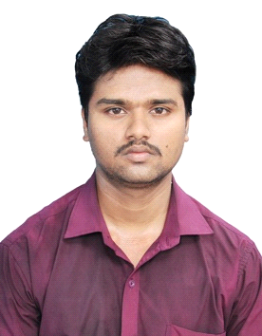 ***Computer Science Professional***

**Email :** [aruljo6991@gmail.com](mailto:aruljo6991@gmail.com). **Mobile :** 9514289777. **Address :** No.154, Pillaiyar kovil st, Pallipudhupet, Villupuram 605 106.

**CAREER OBJECTIVE** **:**

To work for an organization which provides me the opportunity to improve my skills and knowledge to growth along with the organization objective.

**PROFILE SUMMARY** **:**

* An enthusiastic fresher with highly motivated and leadership skills having Bachelors of Engineering degree in Computer Science and Engineering.
* Eager to learn new technologies and methodologies.

**EDUCATION QUALIFICATION** **:**

|  |  |  |  |  |
| --- | --- | --- | --- | --- |
| **Course** | **Institution** | **University** | **Year of passing** | **Percentage** |
| B.E (CSE) | University College of Engineering , Villupuram. | Anna University | 2014 – 2018 | 6.79 CGPA 68% |
| H.SC | Ramakrishna Vidyaalaya Matric. Hr. Sec. School , Villupuram. | State Board | 2012 – 2014 | 86.16% |
| SSLC | Little Star English High School , Pandasozhanallur, Puducherry. | State Board | 2011 -2012 | 90.2% |

**AREA OF INTEREST** **:**

* Database Management System.
* Internet of Things (IOT).
* Networking & System Design.

**TECHNICAL SKILLS** **:**

Environment : Windows'7/8/10 & Ubuntu (Linux).

Programming Language : C (basic), Java (core), Python (basic).

**ACHIEVEMENT :**

Have co-ordinates and conducts the event "CODFUSO" means C programming quiz competition, in Agnimitra 2k17 at University College of Engineering, Villupuram.

**PROJECT/WORKSHOP** **:**

* Did major project “**IOT BASED FLOOD ALERTING SYSTEM** “at **UNIVERSITY COLLEGE OF ENGINEERING, VILLUPURAM during Jan-Mar 2018. (**Link : http://ijartet.com/3393/v5s09mar2018idhaya/conference).
* Attended workshop on **“XML AND WEB SERVICES”** organized by the Department of Computer Science and Engineering during 19th August 2015.

**ROLES AND RESPONSIBILITIES** **:**

* Strong motivational and leadership skills.
* Be a good Co-ordinator.
* Ability to work as individual as well as in group.

**CO**-**CURRICULAR ACTIVITIES** **:**

* National Service Scheme.
* Paper Presentation.
* Workshop Attended.

**EXTRA**-**CURRICULAR ACTIVITIES** **:**

* Reading newspaper.
* Playing Chess.

**PESONAL DETAILS** **:**

Father’s Name : N.Mani.

Date of Birth : 07-10-1996.

Language Known : Tamil , English.

**DECLARATION** **:**

I do hereby declare that the above statements mentioned in my resume are true and correct to the best of my knowledge and belief.

(M.ARULJOTHI)